**Regular Expression:**

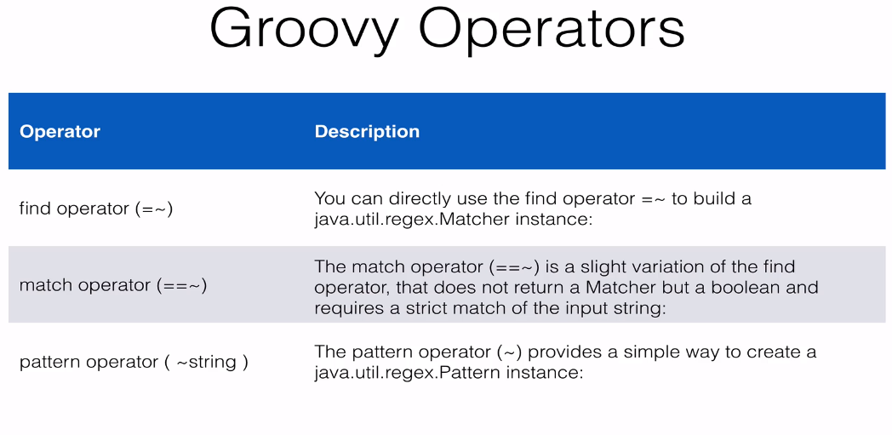

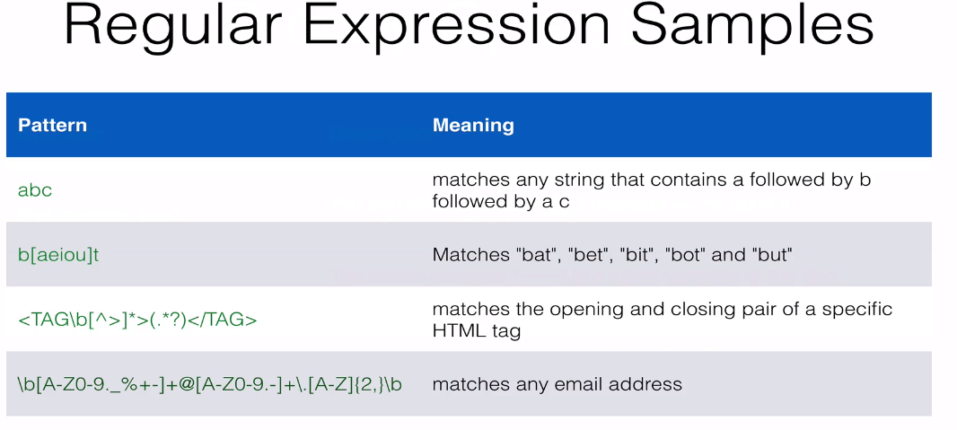

//java sample pattern  
  
import java.util.regex.*;  
Pattern pattern = Pattern.compile("abc") //if we change pattern as "a\b" then only a is considered as pattern   
println pattern   
println pattern.class   
  
//what pattern looks like in java   
String slashy = /a\b/ //slashy string where need to escape backward slash but problem lies what if we  have to use forward slash consider below example   
String url = $/http://abc.com/blog/$  //here we can use dollor sign, if our string has forward slash  
  
println slashy.class  
  
def patterng = ~ /a\b/  
//The pattern operator (~) provides a simple way to create a java.util.regex.Pattern instance:  
println patterng.class  
  
  
  
//find | match   
def text = "Being a Cleveland Sport Fan is no way to ho through life " //true  
  
def patterneg = ~/Cleveland Sport Fan/  
def finder = text =~patterneg // you can directly use the find operator =~ to build a java.util.regex.Matcher instance:  
def matcher= text ==~patterneg //The match operator (==~) is a slight variation of the find operator, that does not return a Matcher but a boolean and requires a strict match of the input string  
  
println finder  
​println finder.size()  
println matcher​